|  |  |
| --- | --- |
| **Front End Development**  Diploma in IT, ISF  2018/19 Semester 2 | Week **5** |
| 4 Hours |
| **CSS Layout with Flexbox and Grid** | |

In this practical you will learn the following:

* Creating a navigation bar using flexbox.
* Arranging and aligning items in flexbox container.
* Creating a 3 rows by 2 columns page layout using grid.
* Creating a responsive page layout for best viewing experience in devices with various screen size.

**Reference**

* Read chapter 16 (CSS Layout with Flexbox and Grid) from the textbook.
* Read chapter 17 (Responsive Web Design) from the textbook.
* Watch the video course under the topic **CSS Essentials Training 2** from the link below:

<https://www.lynda.com/CSS-tutorials/CSS-Essential-Training-2/569189-2.html>

You will have to sign in with your NP email address to watch the video.

If you have any question, please contact your tutor via Microsoft Teams.

**Activities**

Before starting the activity tasks, do the followings:

* Create a Visual Studio Project: ***Week5Practical***
* Download the *Week5Practical_Start.zip* file from MeL, unzip the file and places all the files in the folder created by Visual Studio for the ***Week5Practical*** project

**Task 1**

* Read Part III – CSS for Presentation, Chapter 16: CSS Layout with Flexbox and Grid from the textbook to understand how flexbox container works.
* Refer to Exercise 16-1 on Page 427, follow the instructions to edit the ***bakery-styles.css***file in the “css” folder to convert the unordered lists that implements the navigation bar for *bakery.html* page to flexboxes.
* Test the *bakery.html* page in browser that support flexbox (e.g. Chrome, Firefox) to see the change in the navigation bar design.



*bakery.html* page before completing Task 1 -

navigating bar (in red box) is implemented as unordered list



*bakery.html* page after completing Task 1 -

navigating bar (in red box) is converted to flexboxes with CSS

**Task 2**

* Continue to read Part III – CSS for Presentation, Chapter 16: CSS Layout with Flexbox and Grid from the textbook to learn how to control the alignment of items in a flexbox container.
* Refer to Exercise 16-2 on Page 434 to 435, follow the instructions to edit the CSS on ***flex-menu.html***file to arrange the menu items nicely on the page.
* Refer to Exercise 16-3 on Page 445, follow the instructions to edit the CSS on ***flex-menu.html***file to fine-tune the flex and order of the menu items.
* Test the *flex-menu.html* page on web browser that support flexbox (e.g. Chrome, Firefox) to see the final arrangement:

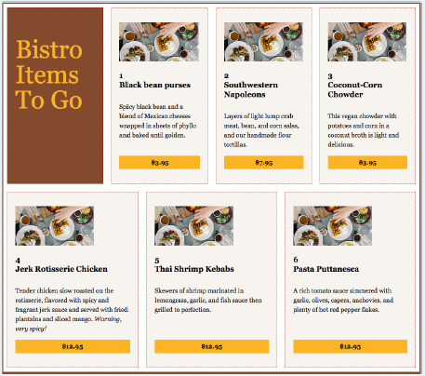

*flex-menu.html* page with flexboxes -

The number of rows and columns for the menus may various, depending on screen resolution

**Task 3**

* Continue to read Part III – CSS for Presentation, Chapter 16: CSS Layout with Flexbox and Grid from the textbook to understand CSS Grid Layout.
* Refer to Exercise 16-6 on Page 476 to 477, follow the instructions to edit the ***bakery.html*** file and the ***bakery-styles.css*** file in the “css” folder to create a grid layout of 2 columns and 3 rows, and place the header, footer and main content on the grid layout.
* Test the *bakery.html* page on web browser to see the final layout:

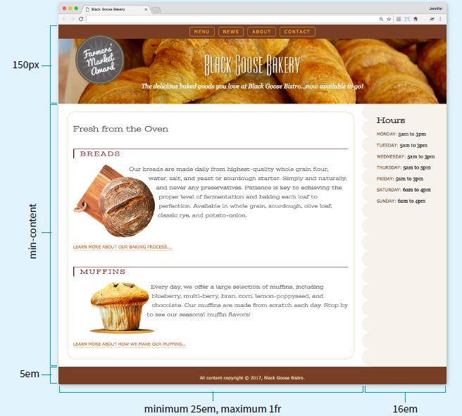

The Black Goose Bakery page (*bakery.html*) with a two-column grid layout

**Optional:** If you want to learn more about grid layout:

* Refer to Exercise 16-4 on Page 461 to 462, follow the instructions to edit the CSS on ***grid.html***file to set up a grid layout.
* Refer to Exercise 16-5 on Page 467 to 468, follow the instructions to edit the CSS on ***grid.html***file to place items on a grid layout.
* Test the *grid.html* page on web browser to see the final layout.

**Task 4**

* Read Part III – CSS for Presentation, Chapter 17: Responsive Web Design from the textbook to understand how flexbox, grid layout and media queries can be used to create web pages that are responsive to devices with various screen size for better reader experiences.
* Open the *bakery.html* file in the Visual Studio project, change the highlighted line below to use a different external CSS file (***bakery-rwd.css***) that we will work on for responsive web design:

|  |
| --- |
| <head>  <meta charset="UTF-8">  <title>Black Goose Bakery</title>  <meta name="viewport" content="width=device-width, initial-scale=1">  <link href="https://fonts.googleapis.com/css?family=Stint+Ultra+Expanded" rel="stylesheet">  **<link rel="stylesheet" href="css/bakery-rwd.css">**  </head> |

* Refer to Exercise 17-1 on Page 508 - 511, follow the instructions to edit the ***bakery-rwd.css***file in the “css” folder to add media queries that change the page layout and some of the display items in flexbox to suit various screen size (viewport).
* Test the *bakery.html* page in browser. Adjust the screen size to view the layout under various sizes of viewport.

Submit the completed practical files to your folder in \\ictspace\FED by Sunday 2359hrs of Week 5.

If you have any questions, please contact your tutor via Microsoft Teams.

== End of Worksheet ==